Locke, Alain LeRoy (1885-1954)

Contributors:

Bridget Chalk (Manhattan College) and

Cocoa Williams (Florida State University)

Sarah Fedirka (The University of Findlay)

SUMMARY:

[insert fig. 1 Portrait of Locke.jpg]

Alain Locke was an American philosopher, editor, and critic whose influence helped to inscribe modernist aesthetics within the history of black artistry, which he defined in philosophical and political as well as artistic terms. His guest editorship of the March, 1925 *Survey Graphic* magazine’s special edition on race, which he titled “Harlem: Mecca of the New Negro” and which he edited and extended to create his anthology *The New Negro: An Interpretation of Negro Life*, is generally considered a seminal moment in the founding of the Harlem Renaissance. Published in 1925, *The New Negro* includes contributions from what Locke called the rising generation of "Negro Youth" writers, including Langston Hughes, Claude McKay, Jessie Fauset, Jean Toomer, and Countee Cullen. Locke's introduction to the volume announced a new age in African American aesthetics, one which abandoned the direct political objectives of racial uplift and dedicated itself to merging folk art with artistic experimentation. Locke was born in Philadelphia, received undergraduate and graduate degrees from Harvard, and was the first African-American Rhodes Scholar. His philosophical theories focused on race relations, cultural relativism, and pluralism, interests he extended to his promotion of writers and artists now associated with the Harlem Renaissance.

MAIN ENTRY:

Alain LeRoy Locke was born Arthur Locke to parents Pliny Ishmael and Mary Hawkins Locke on September 13, 1885 (not 1886 as he would claim) in Philadelphia, Pennsylvania, where he was raised and educated. His father was a lawyer and his mother a teacher and disciple of Rabbi Felix Adler. His paternal grandparents had worked as schoolteachers and missionaries in Liberia, shaping Locke’s passions for education and service. Locke completed his primary and secondary education at the Charles Close School and Central High School, respectively. Locke attended the Philadelphia School of Pedagogy and Practice before entering Harvard in 1904. In 1907, he graduated Phi Beta Kappa from Harvard and became the first African-American to win a Rhodes scholarship to Oxford. Although Locke excelled as an undergraduate, he encountered difficulties continuing his education aboard, as several schools denied him admittance despite being a Rhodes Scholar. Eventually, Locke was accepted at Hertford College before going on to attend both Oxford and the University of Berlin. Upon his return to the United States in 1912, Locke began teaching in the English and philosophy departments at Howard University. In 1916, Locke returned to Harvard to complete a doctoral degree in philosophy. While at Harvard, Locke discovered the philosophies of William James, whose theories on universality served as a counterpoint to Locke’s own developing ideas on cultural pluralism and value theory. Locke returned to Howard after earning his PhD in 1918. During his tenure at Howard he met and began his mentorship of Zora Neale Hurston, putting her and Langston Hughes in contact with Charlotte Osgood Mason, who would become their patron. Also during this time Locke embraced the Bahá'í faith. He was homosexual, though not publically so, and never married. He died in New York City in 1954.

While trained as a philosopher, Locke made his name as a critic and editor central to the development of the Harlem Renaissance. His role as editor of the seminal anthology *The New Negro: An Interpretation* (1925) stands as his enduring achievement and earned him the monikers “dean,” “father,” and “midwife” of the Harlem Renaissance. However, he planned his unfinished *The Negro in American Culture* to be his greatest contribution to American letters. (It was completed by Margaret Just Butcher in 1954 based on Locke’s notes.)

[insert fig. 2 The New Negro Title Page.jpg]

The *New Negro* evolved out of a special "Harlem" issue of *Survey Graphic* magazine that Locke had edited the previous year. It compiled essays, short stories, poetry, drama, art, and photography by leading and emerging African American writers and artists, including Langston Hughes, Claude McKay, Jessie Fauset, Jean Toomer, and Countee Cullen. Locke's own pioneering essays in the volume outline a new political identity for African Americans in the early twentieth century and tie this emerging agency to trends in aesthetic expression.

In the anthology’s title essay, Locke defines the current phase of Negro development and explores the evolving social psychology of American race relations. Specifically, he situates his “cultural racism” within his developing theories of “cultural pluralism.” Locke considered himself a “cultural cosmopolitan” who believed racial equality would evolve from cooperative cultural interchange. *The New Negro* promotes such interchange: itincludes white and black contributors, situates American nationalism within an international context, and connects the “New Negro” to an ancient African past while arguing for his significance to contemporary white America. Whereas the "old" Negro was a "stock figure" of Southern prejudice and sentimentality, the New Negro is increasingly confident about his role in American life. Locke argues that the migration to Northern cities by Southern blacks during and after World War I should be understood not simply as a consequence of economic and political conditions but rather as motivated by a broad "new vision of opportunity, of social and economic freedom" (*The New Negro* 6). The congregation of blacks in cities, moreover, unified disparate genealogies and class positions, and Locke contends that Harlem, while a “race capital,” stands as the "the laboratory of great race-welding" (7) and exemplifies the potential for creative empowerment made possible through this geographical shift. According to Locke, the New Negro must avoid submission to whites and angry "counter-prejudice" against them and instead evolve from "social disillusionment to race pride" (10). A crucial route to this racial self-actualization, he argues, runs through creative expression, specifically through a cultural resurgence in Negro art, a “Negro Renaissance.” In essays on "The Negro Spirituals" and "African Ancestral Art," Locke considers the multiple strands of the African American aesthetic inheritance and suggests that these valuable resources can be combined with modernist strategies to achieve a "racial idiom" in Negro artistic expression.

[insert fig.3 link to lecture <http://alainlocke.com/?page_id=42>]

Famously, Locke disagreed with W.E.B. Dubois's assessment of the imperatives of African American art, which Dubois saw as the political obligation to represent the race in uplifting ways. In the essay "Art and Propaganda" (1928), Locke insisted that free self-expression was the only way to produce authentic art, instead of propaganda that necessarily emphasized the weaker, inferior position of the black race.

[insert fig.4 Alain_LeRoy_Locke.jpg]

Locke's philosophies belong to the American pragmatist tradition and owe a debt to the theories of John Dewey. His philosophical commitment to diversity informed his aesthetic criticism, and while he situated African-American arts within particular cultural and historical traditions, he simultaneously recognized this new mode of racial advancement to be international and invested in modes of aesthetic experimentation characteristic of high modernism.

Locke’s theories were also shaped by the work of anthropologist Franz Boas. Like Boas, he looked to transform mainstream understanding of race. While he acknowledged race to have a biological component, Locke recognized racial categories as being socially constructed. He outlines his philosophical ideologies in the autobiographical “psychograph” that introduces his essay “Values and Imperatives” (1935), a work that argues human values are socially determined attitudes that shape behavior. Locke championed racial equality in his writings as well as through his participation in the Racial Amity Conventions. His belief that education was essential to developing racial tolerance shaped his role as first African-American president of the American Association for Adult Education.

Locke’s other major works include Race Contacts and Interracial Relations: Lectures on the Theory and Practice of Race (1916), *The Negro and His Music* (1936), *The Negro in Art* (1940), *When Peoples Meet: A Study in Race and Culture Contacts* (1947), co-written with Bernhard Stern, and the philosophical essay “Pluralism and Ideological Peace” (1947).

[insert fig.5 link to archival footage https://www.youtube.com/watch?v=o8zEGCP-p6k]

Selected Works

Locke, A. (1928) 'Art or Propaganda?' *Harlem* 1(1): 12-13.

------ (ed.)(1925) *The New Negro: An Interpretation*. New York: Johnson Reprint Corporation.

*--*----(1983) *The Critical Temper of Alain Locke: A Selection of His Essays on Art and Culture*. Ed. Jeffrey Stewart. New York: Garland.

------ (1989) *The Philosophy of Alain Locke: Harlem Renaissance and Beyond*. Ed. L. Harris. Philadelphia: Temple University Press,

------ (1992) *Race Contacts and Interracial Relations*. Ed. Jeffrey Stewart. Washington, D.C.: Howard University Press

------ (2012) *The Works of Alain Locke (The Collected Black Writings Series)*. Ed. Charles Molesworth. Oxford: Oxford University Press.

Further Reading

Carter, J. (2012) 'Alain LeRoy Locke.' *The Stanford Encyclopedia of Philosophy*. <http://plato.stanford.edu/archives/sum2012/entries/alain-locke/>.

Harris, Leonard. Ed. *The Philosophy of Alain Locke: Harlem Renaissance and Beyond*.

Philadelphia: Temple UP, 1989.

Harris, L and Molesworth, C. (2010) *Alain L. Locke: The Biography of a Philosopher.* Chicago, University of Chicago Press.

# Harris, L. (ed.) (1999) *The Critical Pragmatism of Alain Locke: A Reader on Value Theory, Aesthetics, Community, Culture, Race, and Education*. Lanham, MD: Rowan and Littlefield.

Linnemann, Russell. Ed. *Alain Locke: Reflections on A Modern Renaissance Man*. Baton: Louisiana State UP, 1982. Print.

Molesworth, Charles. Ed. *The Works of Alain Locke*. New York: Oxford UP, 2012. Print.

Washington, Johnny. *A Journey into the Philosophy of Alain Locke*. New York: Greenwood P, 1994. Print.

---. *Alain Locke and Philosophy: A Quest for Cultural Pluralism*. New York: Greenwood

P, 1986. Print.

Multimedia

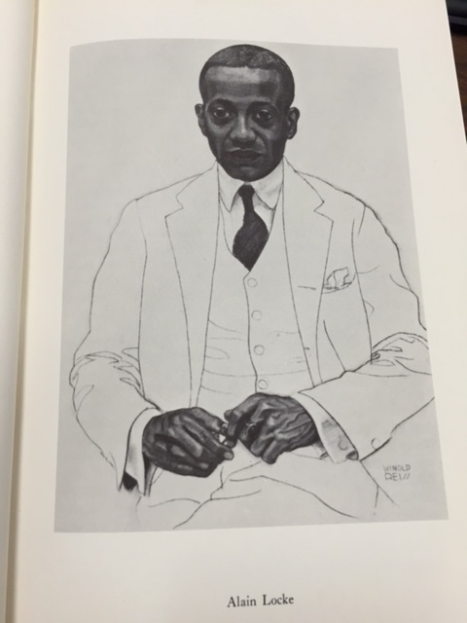

1) Portrait of Locke by Winold Reiss for

*The New Negro: An Interpretation* (1925)

Photo by Bridget Chalk

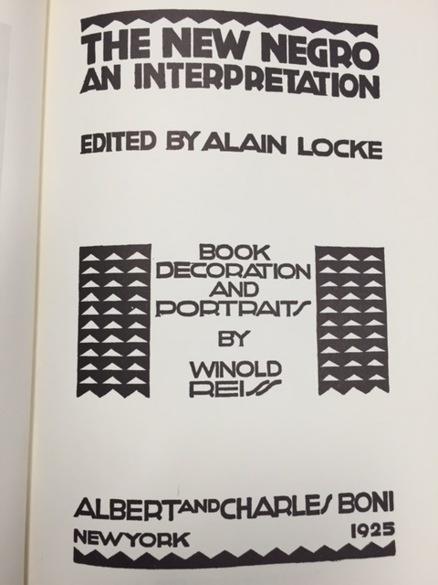

2) Title Page of *The New Negro*

Photo by Bridget Chalk

3) Link to audio clip from lecture, "The Negro Spirituals," as well as three short video clips:

<http://alainlocke.com/?page_id=42>

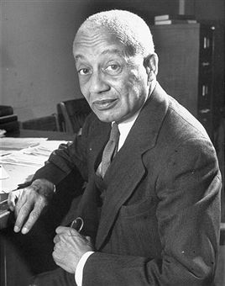

4) 1946 Photograph of Locke by Alfred Eisenstaedt.

"Alain LeRoy Locke" by Alfred Eidsenstaedt. Licensed under Fair use via Wikipedia - http://en.wikipedia.org/wiki/File:Alain_LeRoy_Locke.jpg#/media/File:Alain_LeRoy_Locke.jpg

5) Link to 1937 Footage of Locke (National Archives)

https://www.youtube.com/watch?v=o8zEGCP-p6k